KL143/6S2

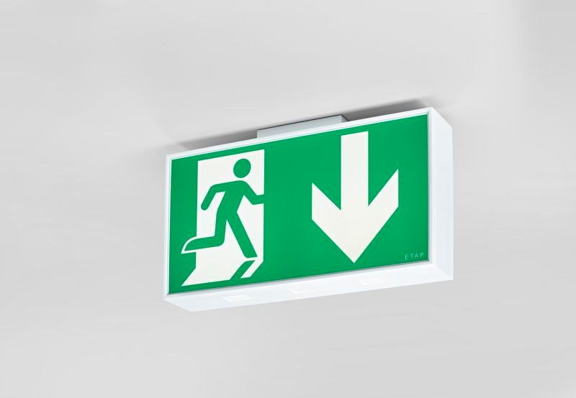
Large emergency luminaire for single or double sided signage. Autonomous luminaire (contains battery). Dimensions: 420 mm x 82 mm x 220 mm. White polycarbonate housing, mounting against the wall, ceiling, or perpendicular to the wall. Connector with screwless wire terminals (up to 2.5 mm²), allows for throughwiring. Lumen output in emergency mode: 110 lm. Power consumption in standby: 3.3 W. Voltage: 220-240V. The perception distance of the pictogram is 40 m. Autonomy: 180 minutes. The luminaire contains lamp data, battery date and type as required according to EN 60598-2.22. Battery: 4 x NiMh 1,2V 2,2Ah. Automatic functional test every week, duration every test 13 weeks, in accordance to EN 50172 and EN 62034. Monitoring and control via ESM software for central maintenance. Polarity independent connection via two wire BUS communication. Maintained/non maintained mode selectable, preset for most common application. Electrical insulation class: class II. Photobiological safety IEC/TR 62778: RG1. Impact-resistant polycarbonate housing, RAL9003 - signal white. IP protection level: IP54. IK protection level: IK04. Ambient temperature: 5°C - 35°C. Glowwire: 850°C. 5 years warranty on luminaire, light source, driver and battery (for autonomous luminaires). Certifications: CE, ENEC. The luminaire has been developed and produced according to standard EN60598-1 in a company that is ISO9001 and ISO14001 certified.

