R23I1R1/NLD

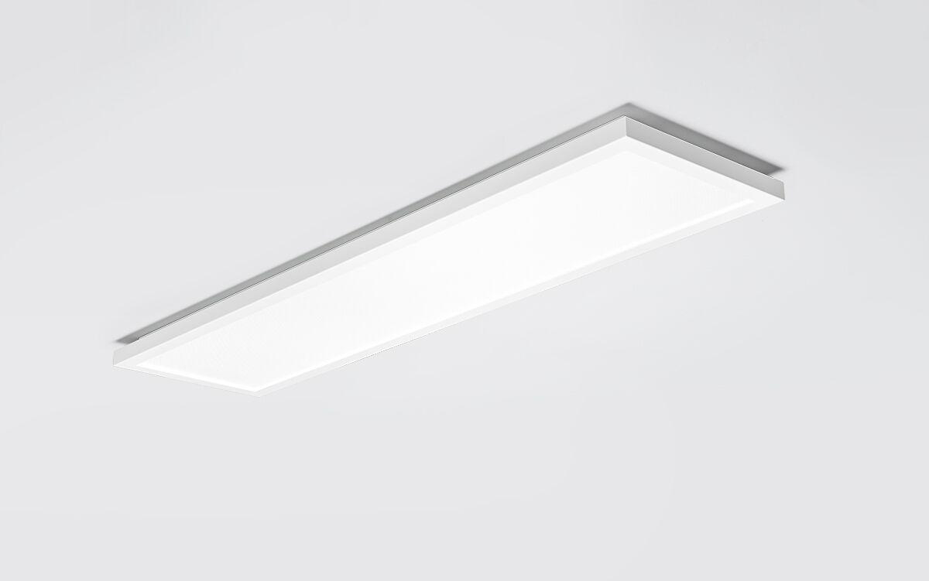
R23 is a surface mounted diffuser flatpanel Diffuser optics, acrylic (PMMA) microprism with diffuser foil, wide-angle light distribution. Dimensions: 1198 mm x 298 mm x 51 mm. Flat panel diffuser for bright and uniform illumination. Luminous flux: 3450 lm, Luminous efficacy: 126 lm/W. Power: 27.5 W, DALI dimmable. Frequency: 50-60Hz AC/DC. Voltage: 220-240V. Electrical isolation class: class II. LED with very good light maintenance; at 50000 hrs the luminaire retains 90% of it's initial flux (Tq=25°C). Correlated colour temperature: 4000 K, Colour rendering ra: 80. Standard deviation colour matching satisfy 3 SDCM. Photobiological safety IEC/TR 62778: RG0. Lacquered sheet steel housing, RAL9003 - signal white. IP protection level: IP20. IK protection level: IK03. Ambient temperature: from -20°C to 35°C. Glowwire: 650°C. 5 years warranty on luminaire and driver. Certifications: CE, ENEC. Luminaire with halogen free leads. The luminaire has been developed and produced according to standard EN60598-1 in a company that is ISO9001 and ISO14001 certified.

