R710R1/LEDW1820SX1

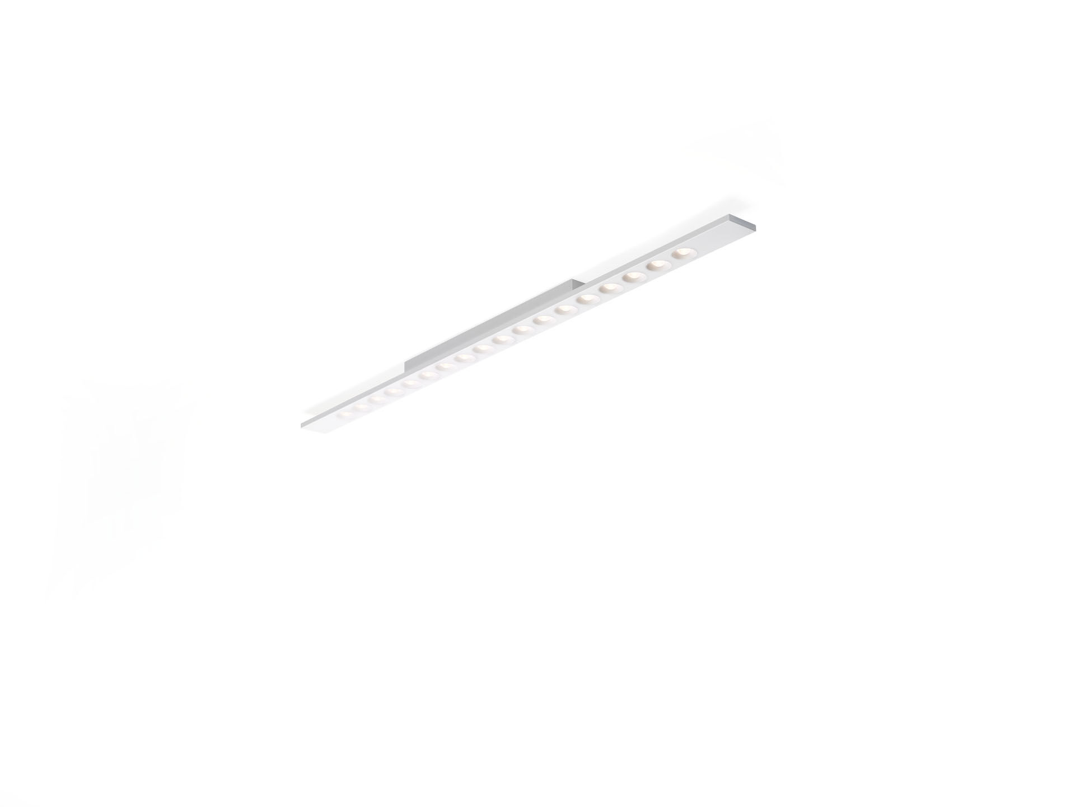
Surface-mounted or suspended LED+LENS luminaire. Led+lens™ optics, polycarbonate (PC) lens and cup, medium wide-angle light distribution. Housing with a visible height of 15 mm and seamless square corners. Lenses recessed in circular cups. Dimensions: 1500 mm x 75 mm x 50 mm. LED+LENS™, a combination of high performance LEDs and individual lenses with a patented surface structure. The lenses are recessed in small cups for a comfortable light experience. Luminous flux: 2250 lm, Luminous efficacy: 118 lm/W. Power: 19.0 W, not dimmable. Frequency: 50-60Hz AC. Voltage: 220-240V. Electrical isolation class: class I. LED with very good light maintenance; at 50000 hrs the luminaire retains 98% of it's initial flux (Tq=25°C). Correlated colour temperature: 3000 K, Colour rendering ra: 80. Standard deviation colour matching satisfy 3 SDCM. LED+LENS™ for glare-free light distribution with UGR <= 16 and luminances @ 65° 1000 Cd/m² conform norm EN 12464-1 for very high visual demands, e.g. quality control, precision tasks. Lacquered sheet steel housing, RAL9003 - white (textured). IP protection level: IP20. Glowwire: 850°C. 5 years warranty on luminaire and driver. Certifications: CE, ENEC. Luminaire with halogen free leads. The luminaire has been developed and produced according to standard EN60598-1 in a company that is ISO9001 and ISO14001 certified.

