R710R1/LEDW1820SX2

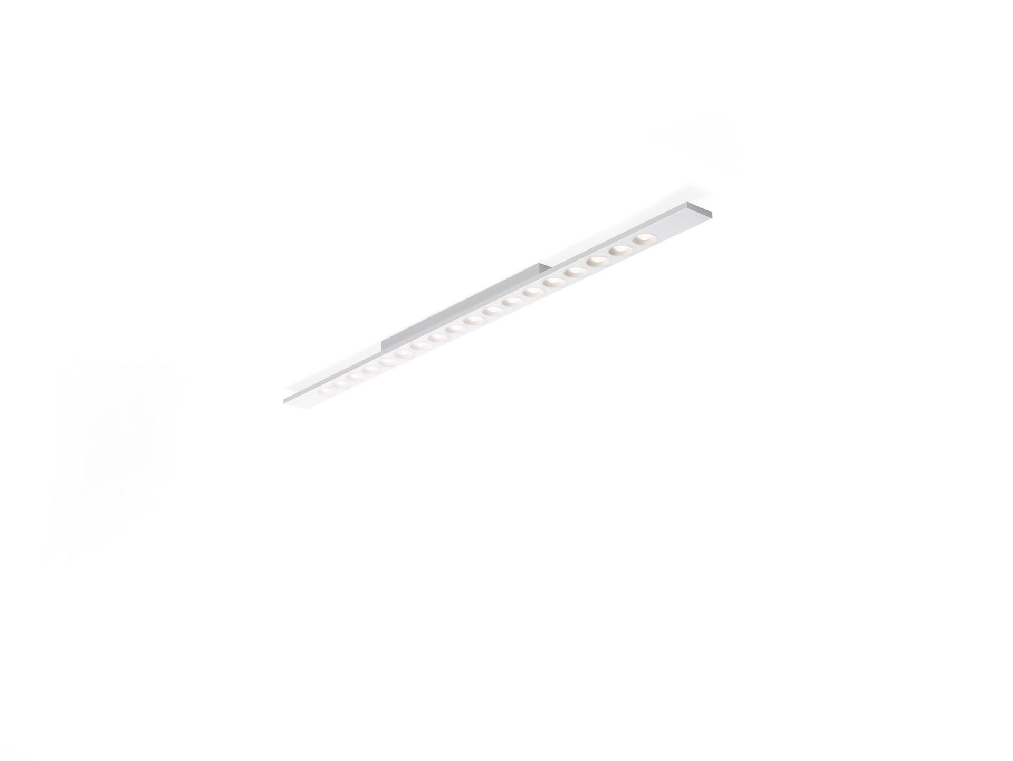
Linear surface-mounted luminaire, LED+LENS™ optics, polycarbonate
(PC) lens and cup, medium wide-angle light distribution. Dimensions: 1500 mm x 75 mm x 50 mm. Housing with a visible height of 15 mm and seamless square corners.
Lenses recessed in circular cups. LED+LENS™, a combination of high-power LEDs and individual lenses
with a patented surface structure. The lenses are recessed in small
cups for a comfortable light experience. Luminous flux: 2250 lm, Luminous efficacy: 118 lm/W. Power: 19.0 W, not dimmable. Frequency: 50-60Hz AC. Voltage: 220-240V. Electrical isolation class: class I. LED with very good light maintenance; at 50000 hrs the luminaire
retains 98% of its initial flux (Tq=25°C). Correlated colour temperature: 3000 K, Colour rendering ra: 80. Standard deviation colour matching satisfy 3 SDCM. LED+LENS™ for glare-free light distribution with UGR <= 16 and
luminances @ 65° 1000 Cd/m² conform norm EN 12464-1 for very high
visual demands, e.g. quality control, precision tasks. Photobiological safety EN 62471: RISK GROUP 1 UNLIMITED. Lacquered sheet steel housing, RAL9006 - white aluminium (textured). IP protection level: IP20. Glowwire: 850°C. 5 years warranty on luminaire and driver. Certifications: CE, ENEC. Luminaire with halogen free leads. The luminaire has been developed and produced according to standard
EN60598-1 in a company that is ISO9001 and ISO14001 certified.

