R831R1/LEDN35D

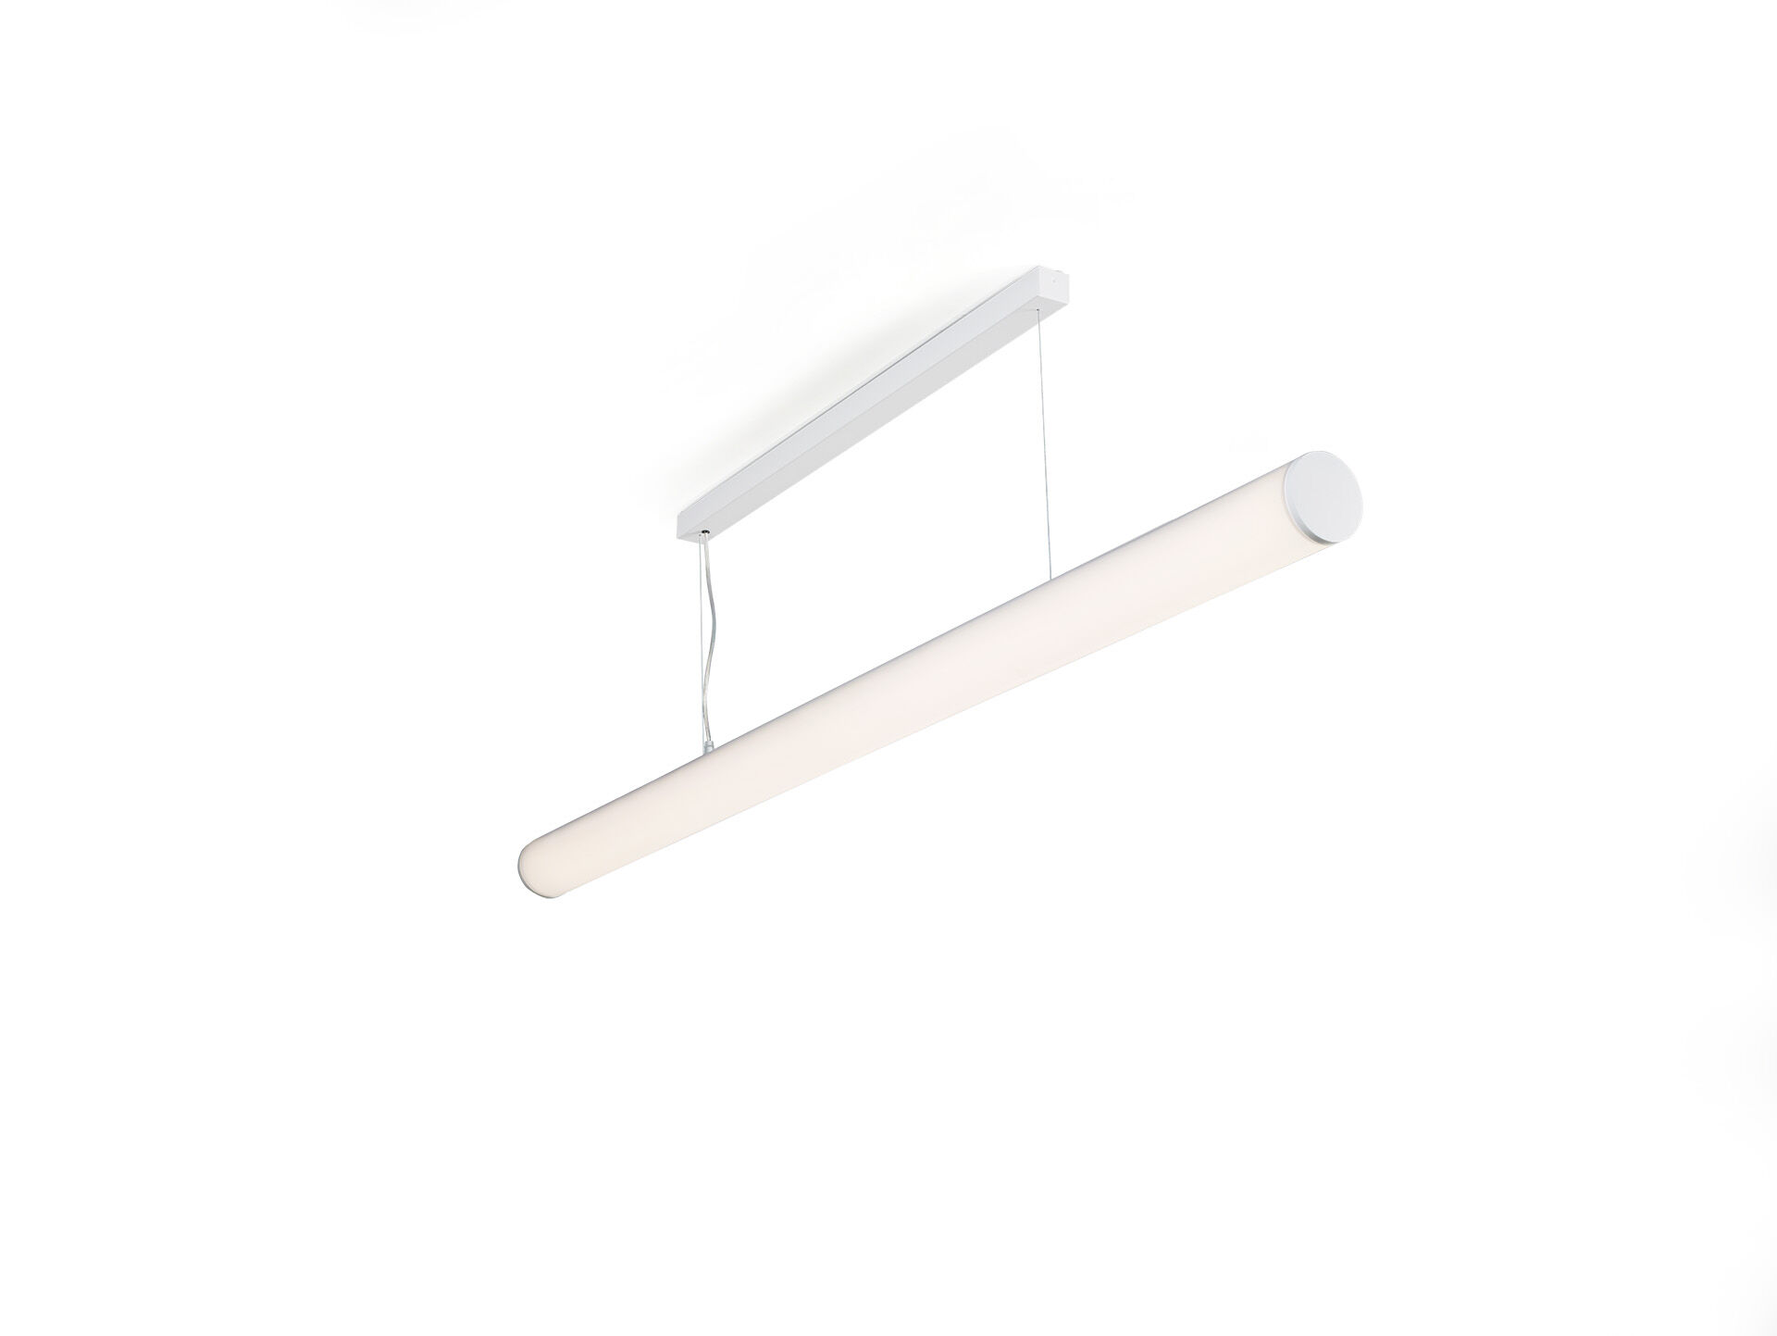
Surface-mounted and suspended diffusor luminaire. Halooptics diffuser optics, polycarbonate (PC) HaloOptics®, wide-angle light distribution. 80 mm diameter, white end-caps, can be mounted in-line with optional endcap accessory. Dimensions: 1542 mm x 80 mm x 121 mm. Tubular HaloOptics diffuser™ for bright and uniform illumination. Luminous flux: 3400 lm, Luminous efficacy: 131 lm/W. Power: 26.0 W, DALI dimmable. Frequency: 50-60Hz AC. Voltage: 220-240V. Electrical isolation class: class I. LED with very good light maintenance; at 50000 hrs the luminaire retains 98% of it's initial flux (Tq=25°C). Correlated colour temperature: 4000 K, Colour rendering ra: 80. Colour consistency (McAdam ellipse): ≤ SDCM. Photobiological safety IEC/TR 62778: RG0. RAL9003 - white. IP protection level: IP20. Replaceable (LED only) light source by a professional. Replaceable control gear by a professional. Energy efficiency class of the light source according to EU regulation 2019/2015: D. Glowwire: 850°C. 5 years warranty on luminaire and driver. Certifications: CE, ENEC. Luminaire with halogen free leads. The luminaire has been developed and produced according to standard EN60598-1 in a company that is ISO9001 and ISO14001 certified.

