U23I2R1/NMD

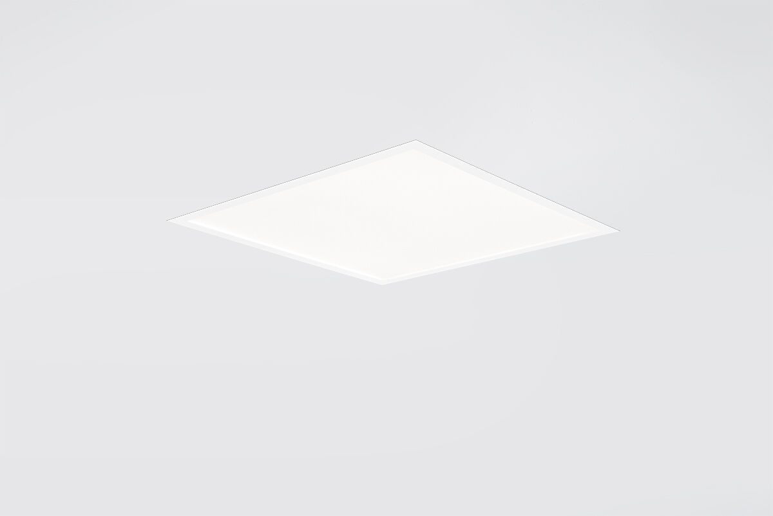
U23 is a recessed diffuser flatpanel Diffuser optics, acrylic (PMMA) microprism with diffuser foil, wide-angle light distribution. Low recessed height. Dimensions: 595 mm x 595 mm x 22 mm. M600, installation as pure lay-in luminaire for modular ceilings with basic exposed tee grid system. Flat panel diffuser for bright and uniform illumination. Luminous flux: 4200 lm, Luminous efficacy: 125 lm/W. Power: 33.5 W, DALI dimmable. Frequency: 50-60Hz AC/DC. Voltage: 220-240V. Electrical isolation class: class II. LED with very good light maintenance; at 50000 hrs the luminaire retains 90% of it's initial flux (Tq=25°C). Correlated colour temperature: 4000 K, Colour rendering ra: 80. Colour consistency (McAdam ellipse): ≤ 3 SDCM. Photobiological safety IEC/TR 62778: RG0. Lacquered sheet steel housing, RAL9016 - traffic white. IP protection level: IP20. IK protection level: IK03. Non-replaceable light source. Replaceable control gear by a professional. Energy efficiency class of the light source according to EU regulation 2019/2015: C. Ambient temperature: -20°C - 35°C. Glowwire: 650°C. 5 years warranty on luminaire and driver. Certifications: CE, ENEC. Luminaire with halogen free leads. The luminaire has been developed and produced according to standard EN60598-1 in a company that is ISO9001 and ISO14001 certified.

