U2B-M110-MI-840-025D

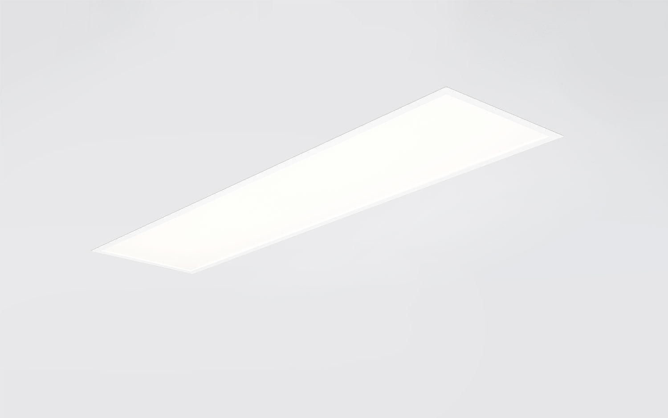
Recessed diffusor with maximum efficiency. Micro-optical foil optics, opal acrylic (PMMA), diffuse, optical deglaring foil light distribution. High luminous flux and efficiency. Dimensions: 1195 mm x 295 mm x 77 mm. M300, installation as pure lay-in luminaire for modular ceilings with basic exposed TEE grid system. Flat panel diffuser with a Micro-optical foil on a clear glass layer for a bright and uniform illumination with wide interdistances. Luminous flux: 2500 lm, Luminous efficacy: 147 lm/W. Power: 17.0 W, DALI dimmable. Frequency: 50-60Hz AC/DC. Voltage: 220-240V. Electrical isolation class: class II. LED with very good light maintenance; at 50000 hrs the luminaire retains 95% of it's initial flux (Tq=25°C). Correlated colour temperature: 4000 K, Colour rendering ra: 80. Standard deviation colour matching satisfy 3 SDCM. Photobiological safety IEC/TR 62778: RG0. Lacquered sheet steel housing, RAL9003 - signal white. IP protection level: IP20/IP40. IK protection level: IK03. Replaceable (LED only) light source by a professional. Replaceable control gear by a professional. Glowwire: 650°C. 5 years warranty on luminaire and driver. Certifications: CE, ENEC. Luminaire with halogen free leads. The luminaire has been developed and produced according to standard EN60598-1 in a company that is ISO9001 and ISO14001 certified.

