U3111/LEDN440D

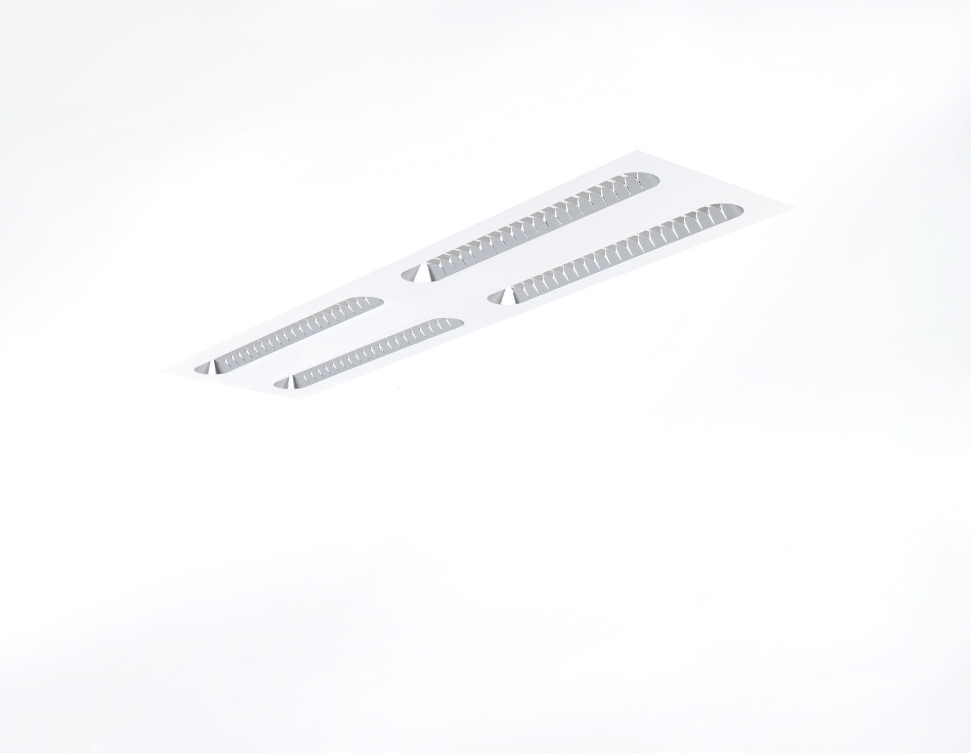
Recessed luminaire with Shielded Lens optics. Shielded lens optics, polycarbonate (PC) with aluminium thin film, medium wide-angle light distribution. Shielding units with rounded ends. Dimensions: 1196 mm x 296 mm x 58 mm. M300, installation as pure lay-in luminaire for modular ceilings with basic exposed TEE grid system. Shielded lens: the light source is hidden from view by shielding units, the light distribution is made with a lens. Two lenses per shield cavity. Luminous flux: 4150 lm, Luminous efficacy: 143 lm/W. Power: 29.0 W, DALI dimmable. Frequency: 50-60Hz AC. Voltage: 220-240V. Electrical isolation class: class I. LED with very good light maintenance; at 50000 hrs the luminaire retains 98% of it's initial flux (Tq=25°C). Correlated colour temperature: 4000 K, Colour rendering ra: 80. Standard deviation colour matching satisfy 3 SDCM. Shielded lens for glare-free light distribution with UGR <= 19 and luminances @ 65° conform norm EN 12464-1 for high visual demands, e.g. display screen equipment. Photobiological safety IEC/TR 62778: RG1. Lacquered sheet steel housing, RAL9003 - white (textured). IP protection level: IP20. Glowwire: 650°C. 5 years warranty on luminaire and driver. Certifications: CE, ENEC. Luminaire with halogen free leads. The luminaire has been developed and produced according to standard EN60598-1 in a company that is ISO9001 and ISO14001 certified.

