U7C-M112-15-830-030D

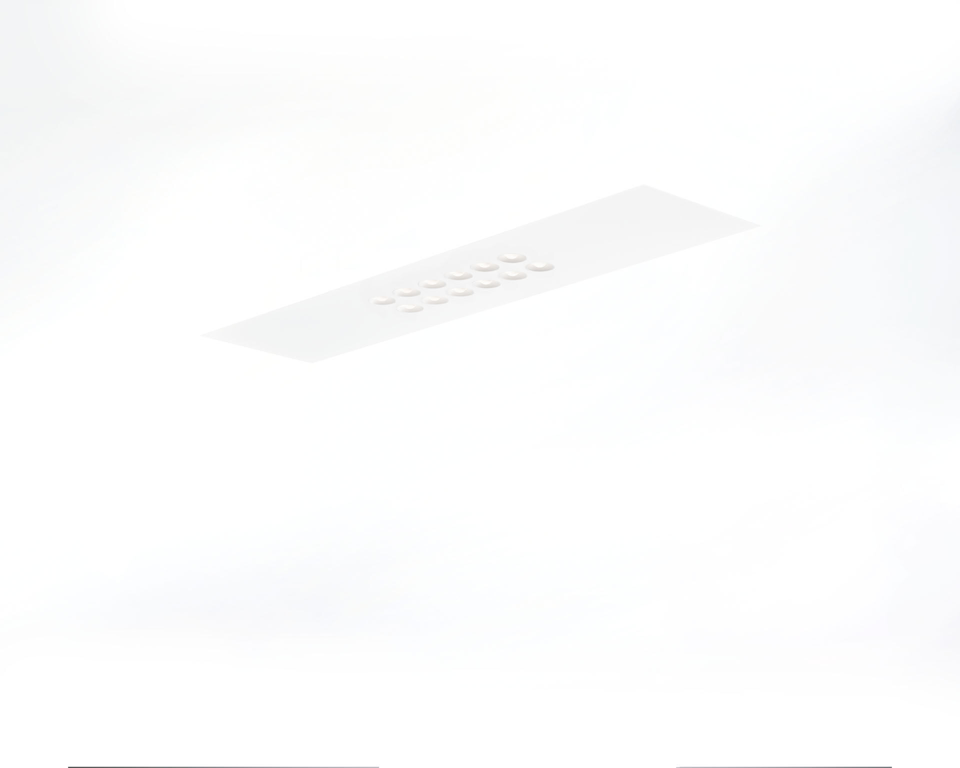
Recessed luminaire with LED+LENS optics. Led+lens™ optics, polycarbonate (PC) lens and cup, medium wide-angle light distribution. Lenses recessed in circular lens cups. Dimensions: 1196 mm x 296 mm x 50 mm. M300, installation as pure lay-in luminaire for modular ceilings with basic exposed tee grid system. LED+LENS™, a combination of high performance LEDs and individual lenses with a patented surface structure. The lenses are recessed in small cups for a comfortable light experience. Luminous flux: 3000 lm, Luminous efficacy: 125 lm/W. Power: 24.0 W, DALI dimmable. Frequency: 50/60Hz AC. Voltage: 220-240V. Electrical isolation class: class I. LED with very good light maintenance; at 50000 hrs the luminaire retains 99% of it's initial flux (Tq=25°C). Correlated colour temperature: 3000 K, Colour rendering ra: 80. Colour consistency (McAdam ellipse): ≤ 3 SDCM. LED+LENS™ for glare-free light distribution with UGR <= 19 and luminances @ 65° 3000 Cd/m² conform norm EN 12464-1 for high visual demands, e.g. display screen equipment. Photobiological safety IEC/TR 62778: RG1. Lacquered sheet steel housing, RAL9003 - white. IP protection level: IP20. Replaceable (LED only) light source by a professional. Replaceable control gear by a professional. Energy efficiency class of the light source according to EU regulation 2019/2015: D. Glowwire: 850°C. 5 years warranty on luminaire and driver. Certifications: CE, ENEC. Luminaire with halogen free leads. The luminaire has been developed and produced according to standard EN60598-1 in a company that is ISO9001 and ISO14001 certified.

