U7C-M248-35-830-075S

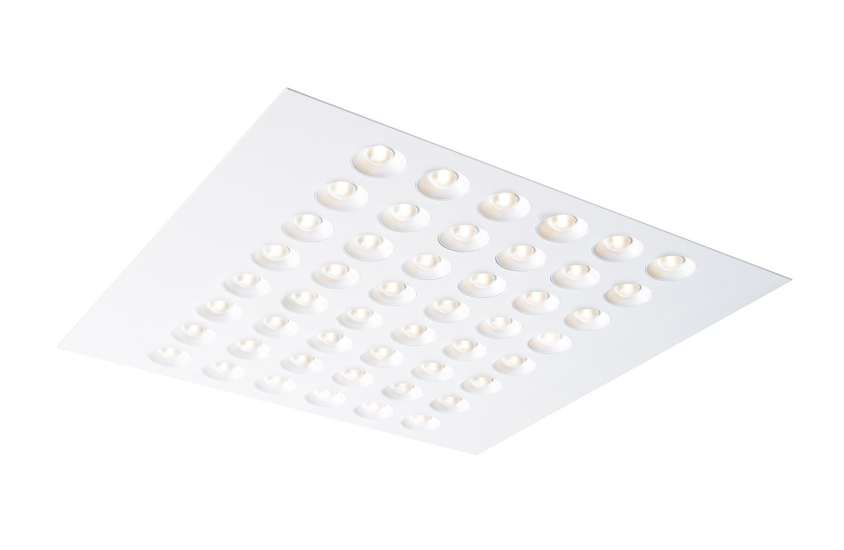
Recessed luminaire with LED+LENS optics. very wide-angle light distribution. Dimensions: 596 mm x 596 mm x 50 mm. M600, installation as pure lay-in luminaire for modular ceilings with basic exposed tee grid system. Luminous flux: 7500 lm, Luminous efficacy: 161 lm/W. Power: 46.5 W, not dimmable. Frequency: 50/60Hz AC. Voltage: 220-240V. Electrical isolation class: class I. LED with very good light maintenance; at 50000 hrs the luminaire retains 96% of it's initial flux (Tq=25°C). Correlated colour temperature: 3000 K, Colour rendering ra: 80. Colour consistency (McAdam ellipse): ≤ 3 SDCM. Photobiological safety IEC/TR 62778: RG1. Lacquered sheet steel housing, RAL9003 - white. IP protection level: IP20. Energy efficiency class of the light source according to EU regulation 2019/2015: C. Glowwire: 850°C. 5 years warranty on luminaire and driver. Certifications: CE, ENEC. Luminaire with halogen free leads. The luminaire has been developed and produced according to standard EN60598-1 in a company that is ISO9001 and ISO14001 certified.

