US3141/LEDN20D

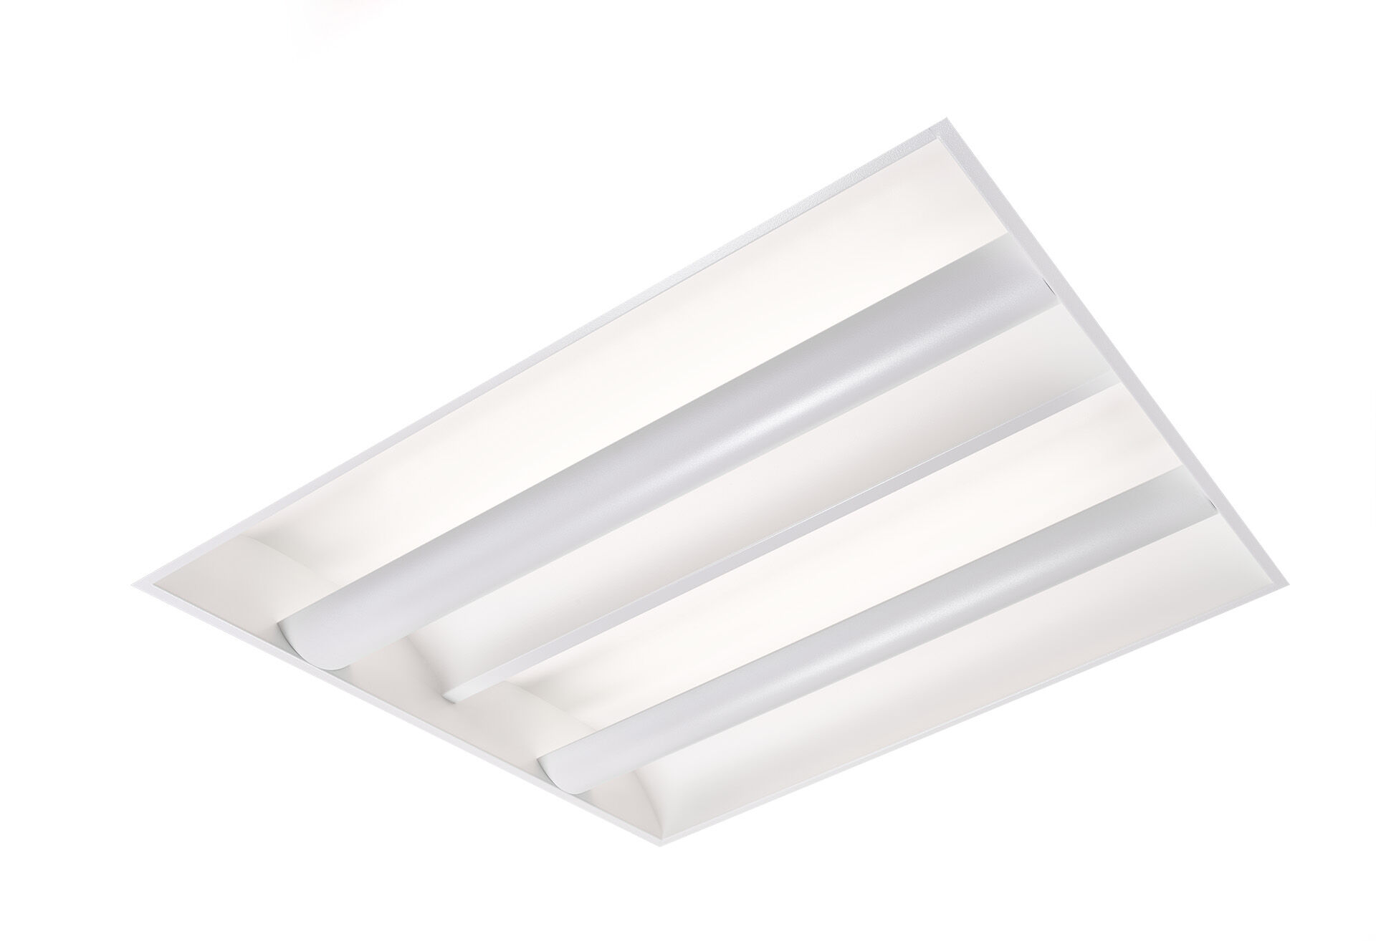
Softlight with 100% indirect lighting. Softlight optics, closed lamp shielding, wide-angle light distribution. White sheet metal lamp shield with arched shape and two curved sheet metal side reflectors, 100% indirect light. Dimensions: 595 mm x 595 mm x 90 mm. M600, installation as pure lay-in luminaire for modular ceilings with basic exposed tee grid system. The lamp shield masks the light source which prevents direct view, the light is reflected by the side reflectors resulting in uniform and bright light distribution. Luminous flux: 2400 lm, Luminous efficacy: 120 lm/W. Power: 20.0 W, DALI dimmable. Frequency: 50-60Hz AC. Voltage: 220-240V. Electrical isolation class: class I. LED with very good light maintenance; at 50000 hrs the luminaire retains 96% of it's initial flux (Tq=25°C). Correlated colour temperature: 4000 K, Colour rendering ra: 80. Colour consistency (McAdam ellipse): ≤ 3 SDCM. Softlight for glare-free light distribution with UGR <= 19 and luminances @ 65° 3000 Cd/m² conform norm EN 12464-1 for high visual demands, e.g. display screen equipment. Photobiological safety IEC/TR 62778: RG0. Lacquered sheet steel housing, RAL9210 - white. IP protection level: IP20. IK protection level: IK03. Replaceable (LED only) light source by a professional. Replaceable control gear by a professional. Energy efficiency class of the light source according to EU regulation 2019/2015: D. Glowwire: 650°C. 5 years warranty on luminaire and driver. Certifications: CE, ENEC. Luminaire with halogen free leads. The luminaire has been developed and produced according to standard EN60598-1 in a company that is ISO9001 and ISO14001 certified.

