US3141/LEDW40D

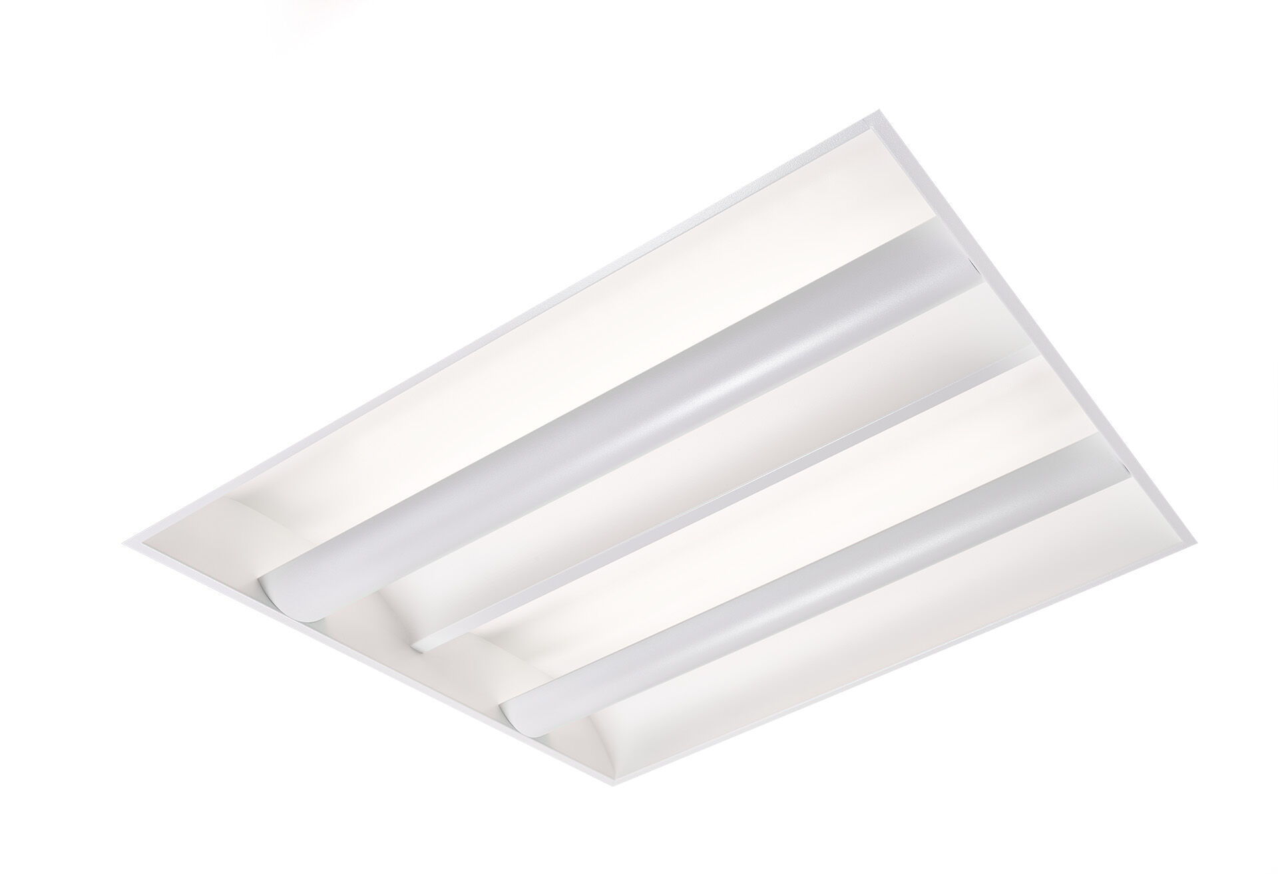
Softlight with 100% indirect lighting. Softlight optics, closed lamp shielding, wide-angle light distribution. White sheet metal lamp shield with arched shape and two curved sheet metal side reflectors, 100% indirect light. Dimensions: 595 mm x 595 mm x 90 mm. M600, installation as pure lay-in luminaire for modular ceilings with basic exposed TEE grid system. The lamp shield masks the light source which prevents direct view, the light is reflected by the side reflectors resulting in uniform and bright light distribution. Luminous flux: 3850 lm, Luminous efficacy: 99 lm/W. Power: 39.0 W, DALI dimmable. Frequency: 50-60Hz AC. Voltage: 220-240V. Electrical isolation class: class I. LED with very good light maintenance; at 50000 hrs the luminaire retains 95% of it's initial flux (Tq=25°C). Correlated colour temperature: 3000 K, Colour rendering ra: 80. Standard deviation colour matching satisfy 3 SDCM. Softlight for glare-free light distribution with UGR <= 22 and luminances @ 65° (value) cd/m² conform norm EN 12464-1 for moderate visual and concentration demands. Photobiological safety IEC/TR 62778: RG0. Lacquered sheet steel housing, specular white. IP protection level: IP20. IK protection level: IK03. Glowwire: 650°C. 5 years warranty on luminaire and driver. Certifications: CE, ENEC. Luminaire with halogen free leads. The luminaire has been developed and produced according to standard EN60598-1 in a company that is ISO9001 and ISO14001 certified.

