V3RDJ0M/N0L0D0X2

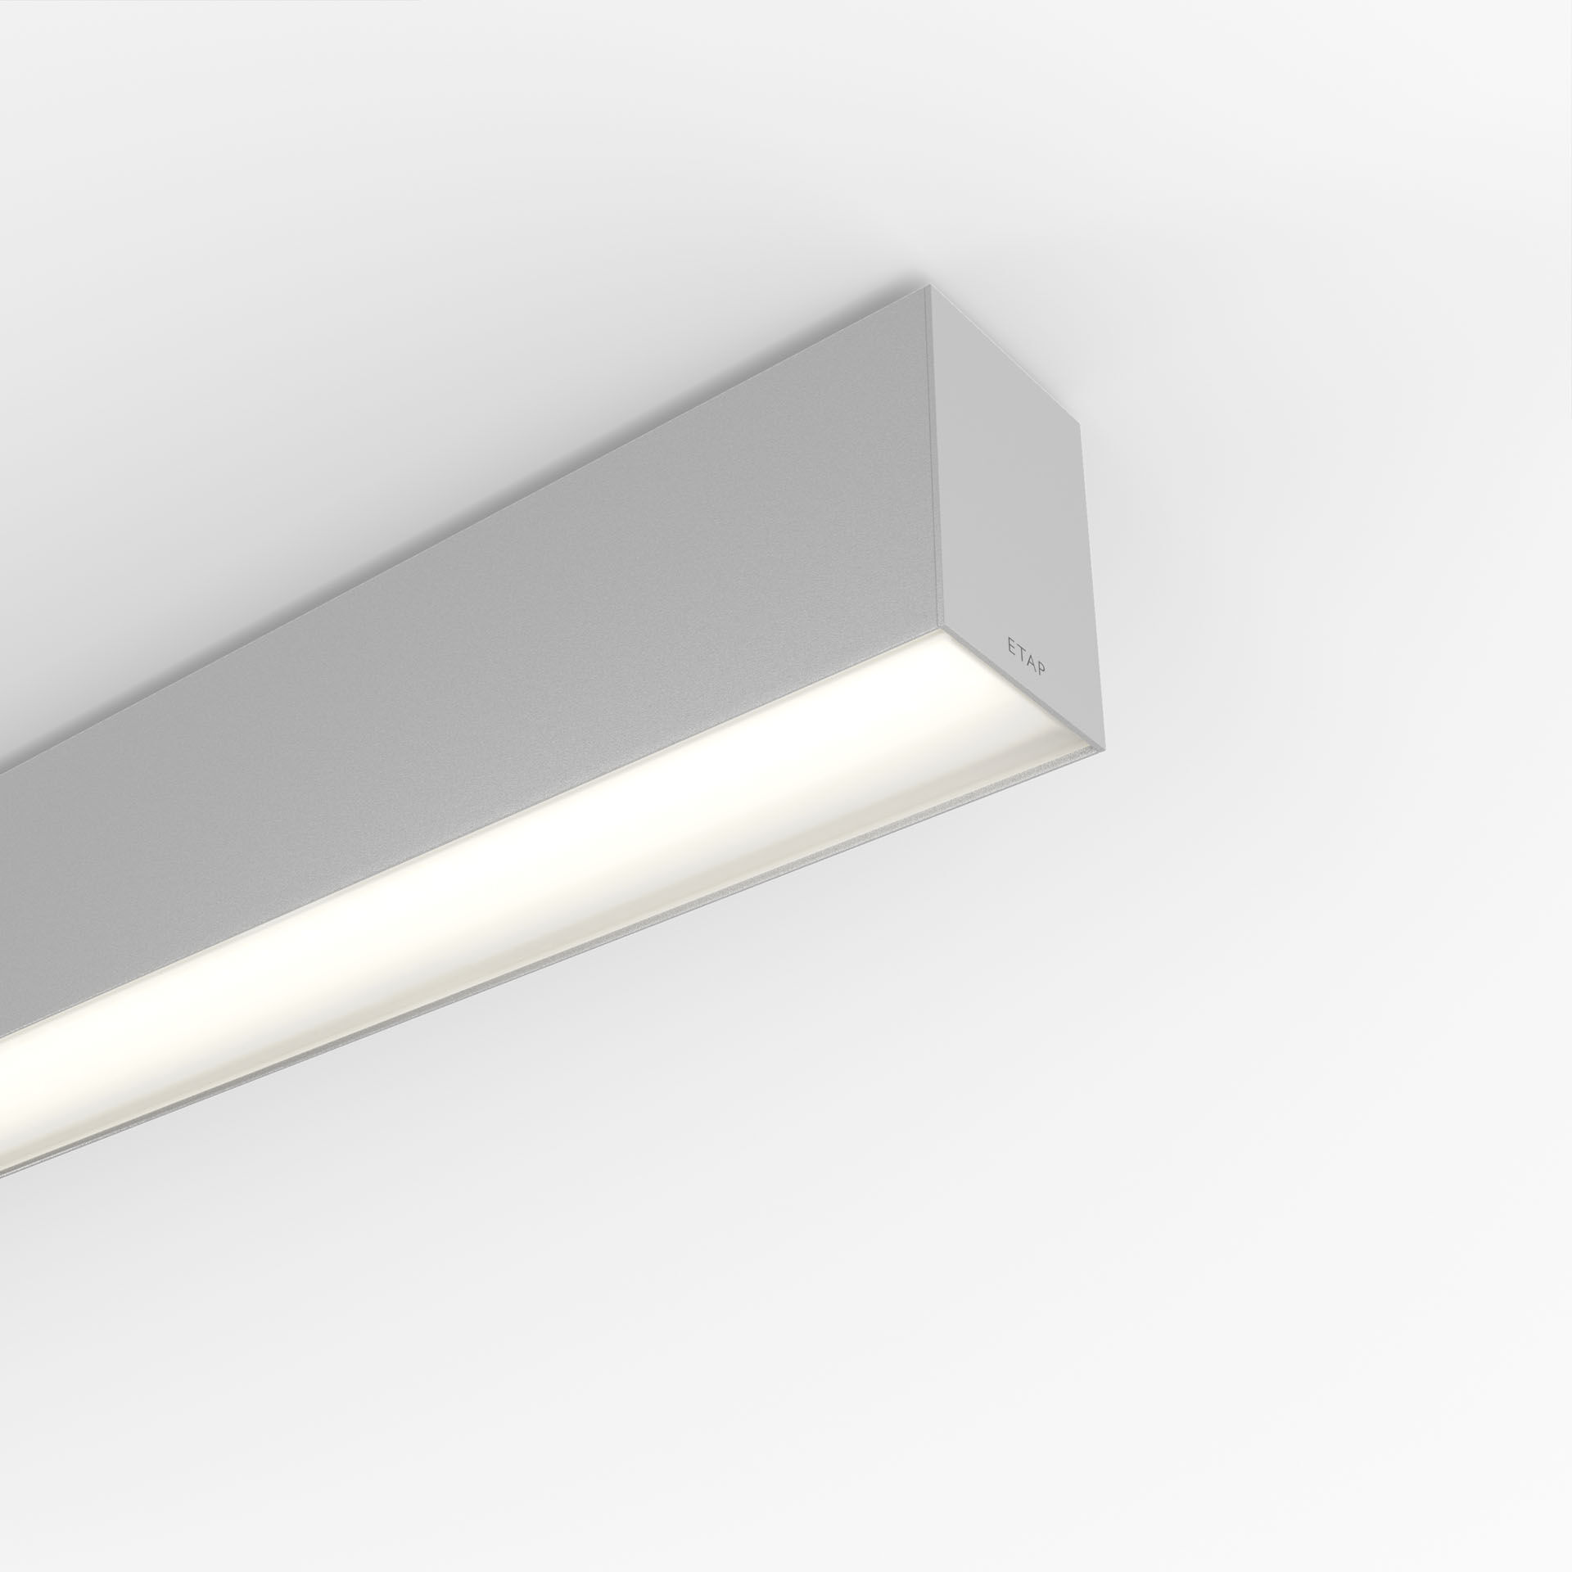
Architectural light line luminaire. Diffuser optics, opal acrylic (PMMA), wide-angle light distribution. Dimensions: 2803 mm x 60 mm x 90 mm. Flat panel diffuser for bright and uniform illumination. Luminous flux: 4700 lm, Luminous efficacy: 124 lm/W. Power: 37.9 W, DALI dimmable. Frequency: 50-60Hz AC. Voltage: 220-240V. Electrical isolation class: class I. LED with very good light maintenance; at 50000 hrs the luminaire retains 98% of it's initial flux (Tq=25°C). Correlated colour temperature: 4000 K, Colour rendering ra: 80. Standard deviation colour matching satisfy 3 SDCM. Lacquered aluminium housing, RAL9006 - white aluminium (textured). IP protection level: IP20. IK protection level: IK07. Glowwire: 850°C. 5 years warranty on luminaire and driver. Certifications: CE, ENEC. Luminaire with halogen free leads. The luminaire has been developed and produced according to standard EN60598-1 in a company that is ISO9001 and ISO14001 certified. Mandatory accessoires for mounting the luminaire: V3H2500, V3H9900, V3H9960.

