V3RDJ0M/W7M0D0X2

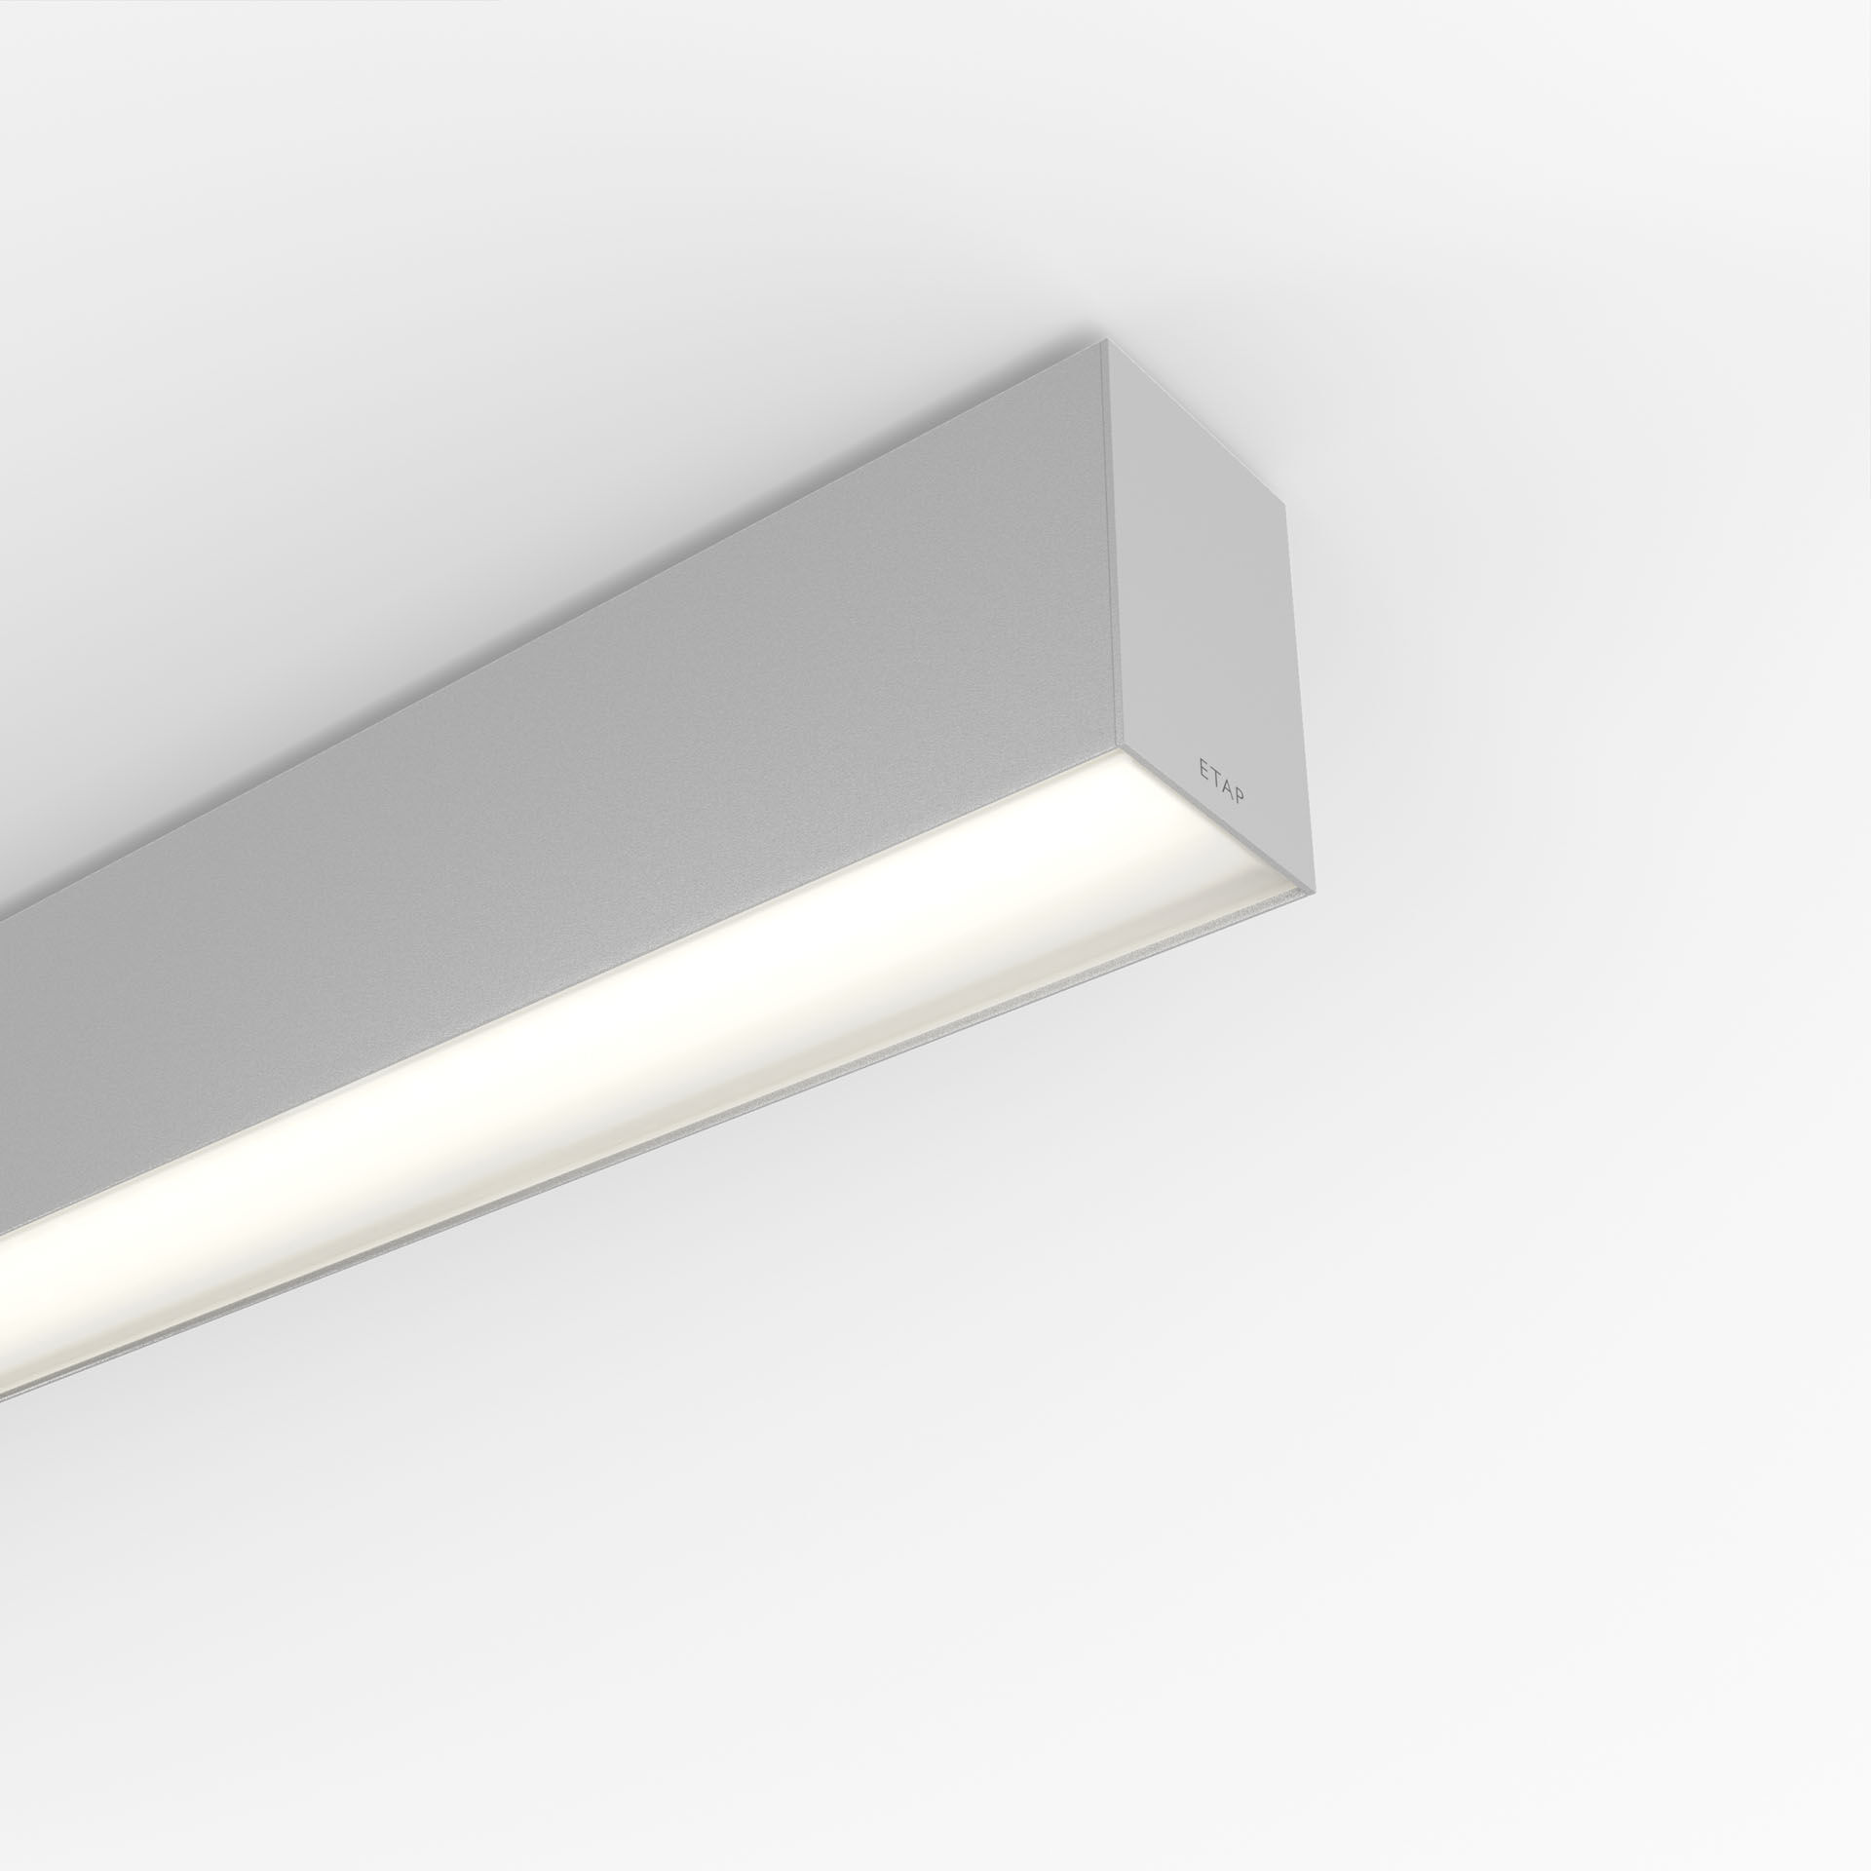
Architectural light line luminaire. Diffuser optics, opal acrylic (PMMA), wide-angle light distribution. Dimensions: 1963 mm x 60 mm x 90 mm. Flat panel diffuser for bright and uniform illumination. Luminous flux: 5150 lm, Luminous efficacy: 116 lm/W. Power: 44.6 W, DALI dimmable. Frequency: 50-60Hz AC. Voltage: 220-240V. Electrical isolation class: class I. LED with very good light maintenance; at 50000 hrs the luminaire retains 97% of it's initial flux (Tq=25°C). Correlated colour temperature: 3000 K, Colour rendering ra: 80. Colour consistency (McAdam ellipse): ≤ SDCM. Lacquered aluminium housing, RAL9006 - aluminium grey. IP protection level: IP20. IK protection level: IK07. Replaceable (LED only) light source by a professional. Replaceable control gear by a professional. Energy efficiency class of the light source according to EU regulation 2019/2015: C. Glowwire: 850°C. 5 years warranty on luminaire and driver. Certifications: CE, ENEC. Luminaire with halogen free leads. The luminaire has been developed and produced according to standard EN60598-1 in a company that is ISO9001 and ISO14001 certified. Mandatory accessoires for mounting the luminaire: V3H2500, V3H9900, V3H9960.

