V3RS10M/N3M0D0X1

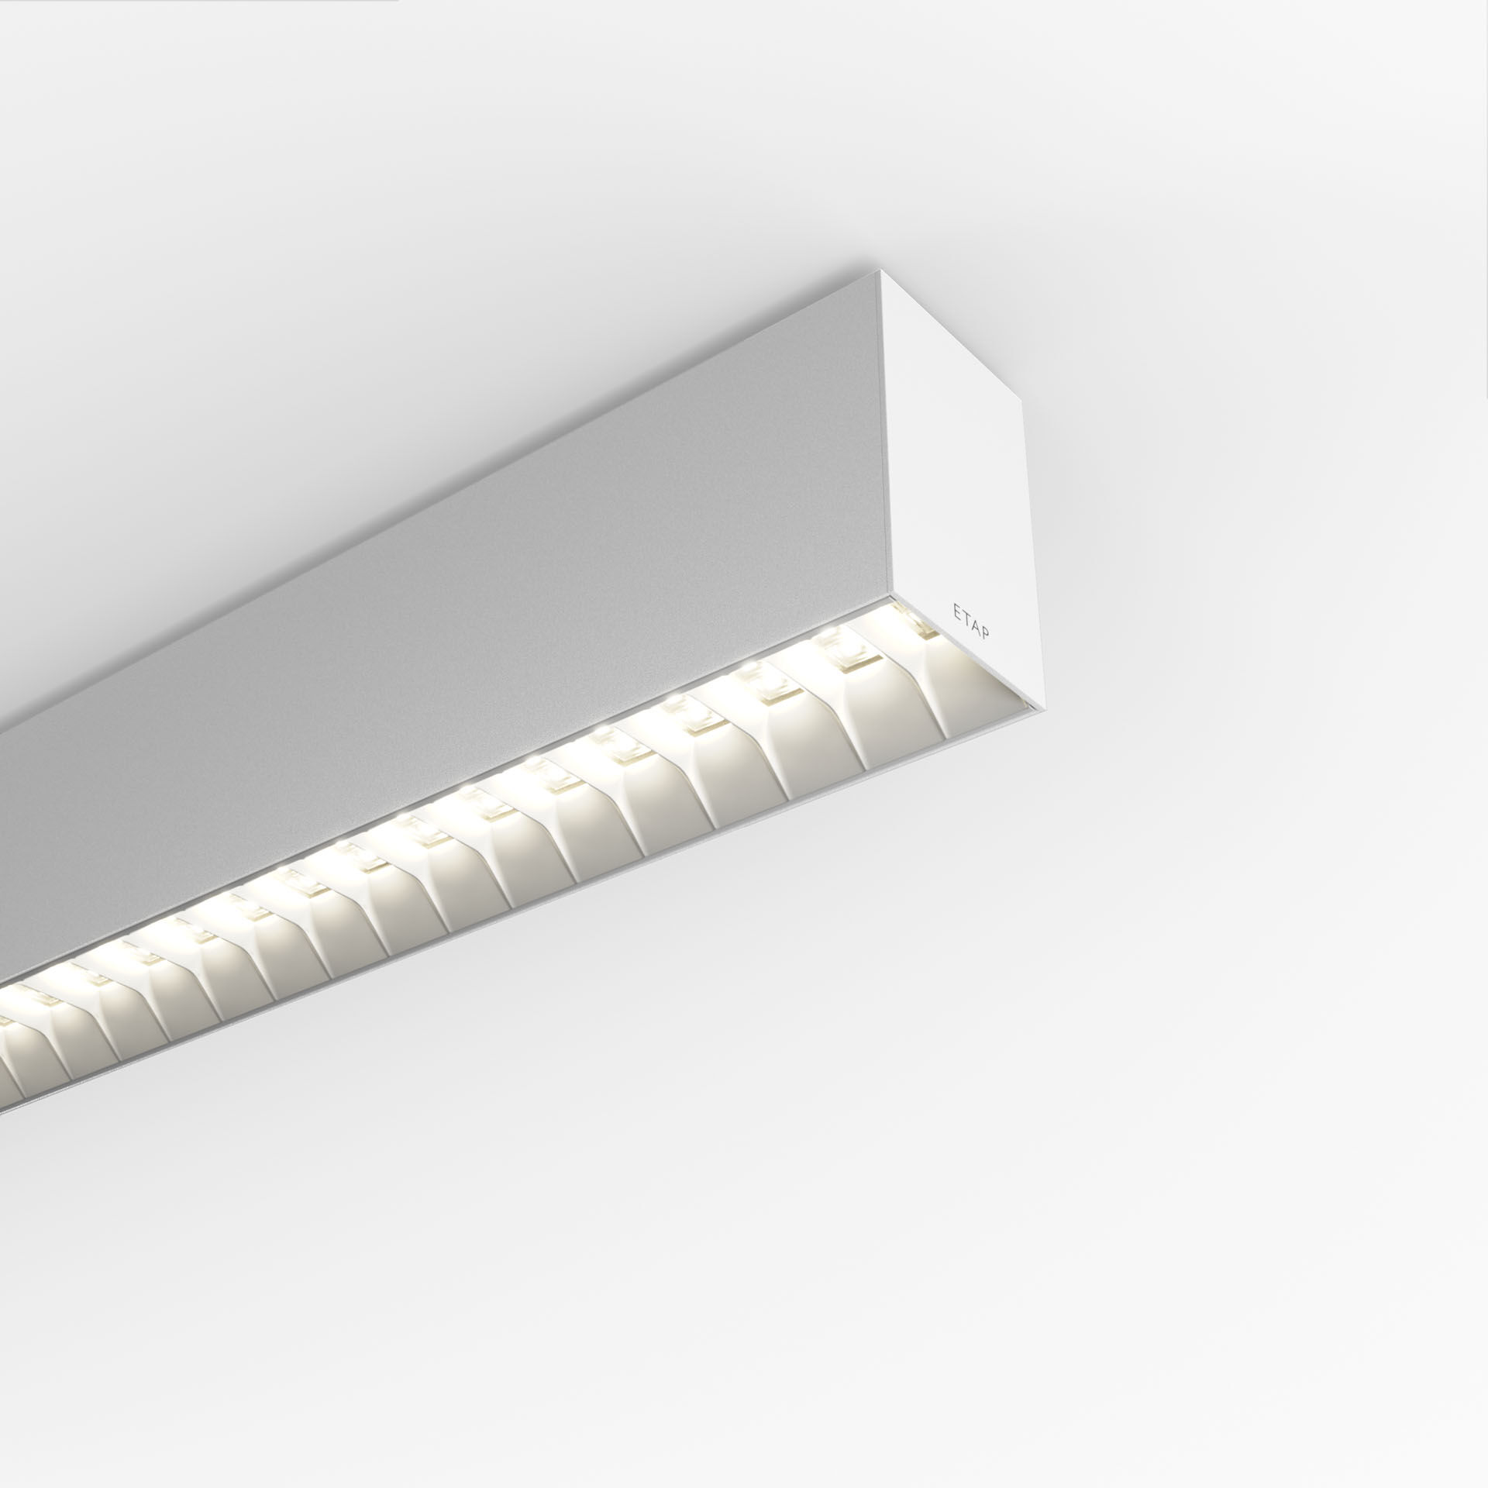
Architectural light line luminaire. Shielded lens optics, white polycarbonate (PC), medium wide-angle light distribution. Dimensions: 1371 mm x 60 mm x 90 mm. Shielded lens: the light source is hidden from view by shielding units, the light distribution is made with a lens. Two lenses per shield cavity. Luminous flux: 2850 lm, Luminous efficacy: 138 lm/W. Power: 20.7 W, DALI dimmable. Frequency: 50-60Hz AC. Voltage: 220-240V. Electrical isolation class: class I. LED with very good light maintenance; at 50000 hrs the luminaire retains 96% of it's initial flux (Tq=25°C). Correlated colour temperature: 4000 K, Colour rendering ra: 80. Standard deviation colour matching satisfy 3 SDCM. Shielded lens for glare-free light distribution with UGR <= 19 and luminances @ 65° 3000 Cd/m² conform norm EN 12464-1 for high visual demands, e.g. display screen equipment. Photobiological safety IEC/TR 62778: RG1. Lacquered aluminium housing, RAL9003 - white (textured). IP protection level: IP20. IK protection level: IK07. Glowwire: 650°C. 5 years warranty on luminaire and driver. Certifications: CE, ENEC. Luminaire with halogen free leads. The luminaire has been developed and produced according to standard EN60598-1 in a company that is ISO9001 and ISO14001 certified. Mandatory accessoires for mounting the luminaire: V3H2500, V3H9900, V3H9960.

