V3SB30M/W5MMD0X1

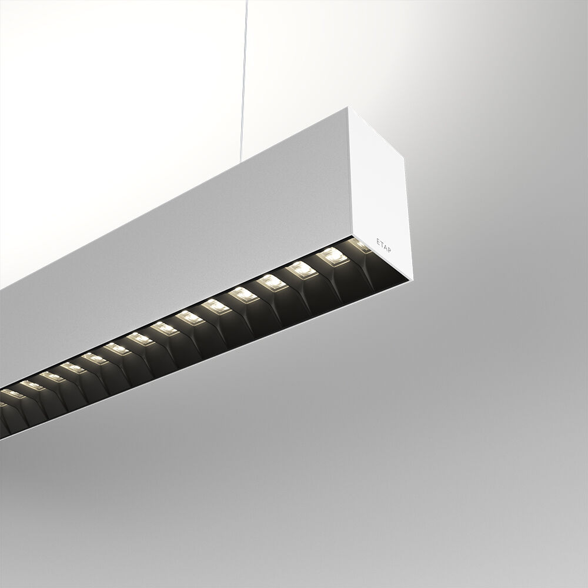
Architectural light line luminaire. Shielded lens optics, black polycarbonate (PC), very wide-angle light distribution. Dimensions: 2283 mm x 60 mm x 90 mm. Shielded lens: the light source is hidden from view by shielding units, the light distribution is made with a lens. Two lenses per shield cavity. Luminous flux: 6250 lm, Luminous efficacy: 132 lm/W. Power: 47.2 W, DALI dimmable. Frequency: 50-60Hz AC. Voltage: 220-240V. Electrical isolation class: class I. Correlated colour temperature: 3000 K, Colour rendering ra: 80. Colour consistency (McAdam ellipse): ≤ SDCM. Shielded lens for glare-free light distribution with UGR <= 16 and luminances @ 65° 1000 Cd/m² conform norm EN 12464-1 for very high visual demands, e.g. quality control, precision tasks. Photobiological safety IEC/TR 62778: RG1. RAL9003 - white. IP protection level: IP20. IK protection level: IK07. Energy efficiency class of the light source according to EU regulation 2019/2015: C. Glowwire: 650°C. 5 years warranty on luminaire and driver. Certifications: CE, ENEC. Luminaire with halogen free leads. The luminaire has been developed and produced according to standard EN60598-1 in a company that is ISO9001 and ISO14001 certified. Mandatory accessoires for mounting the luminaire: ACC-HI00-X01, V3-HI01-5P-1500, V3-HI02-5P-1500.

