V3SDJ0M/N5LLD0X2

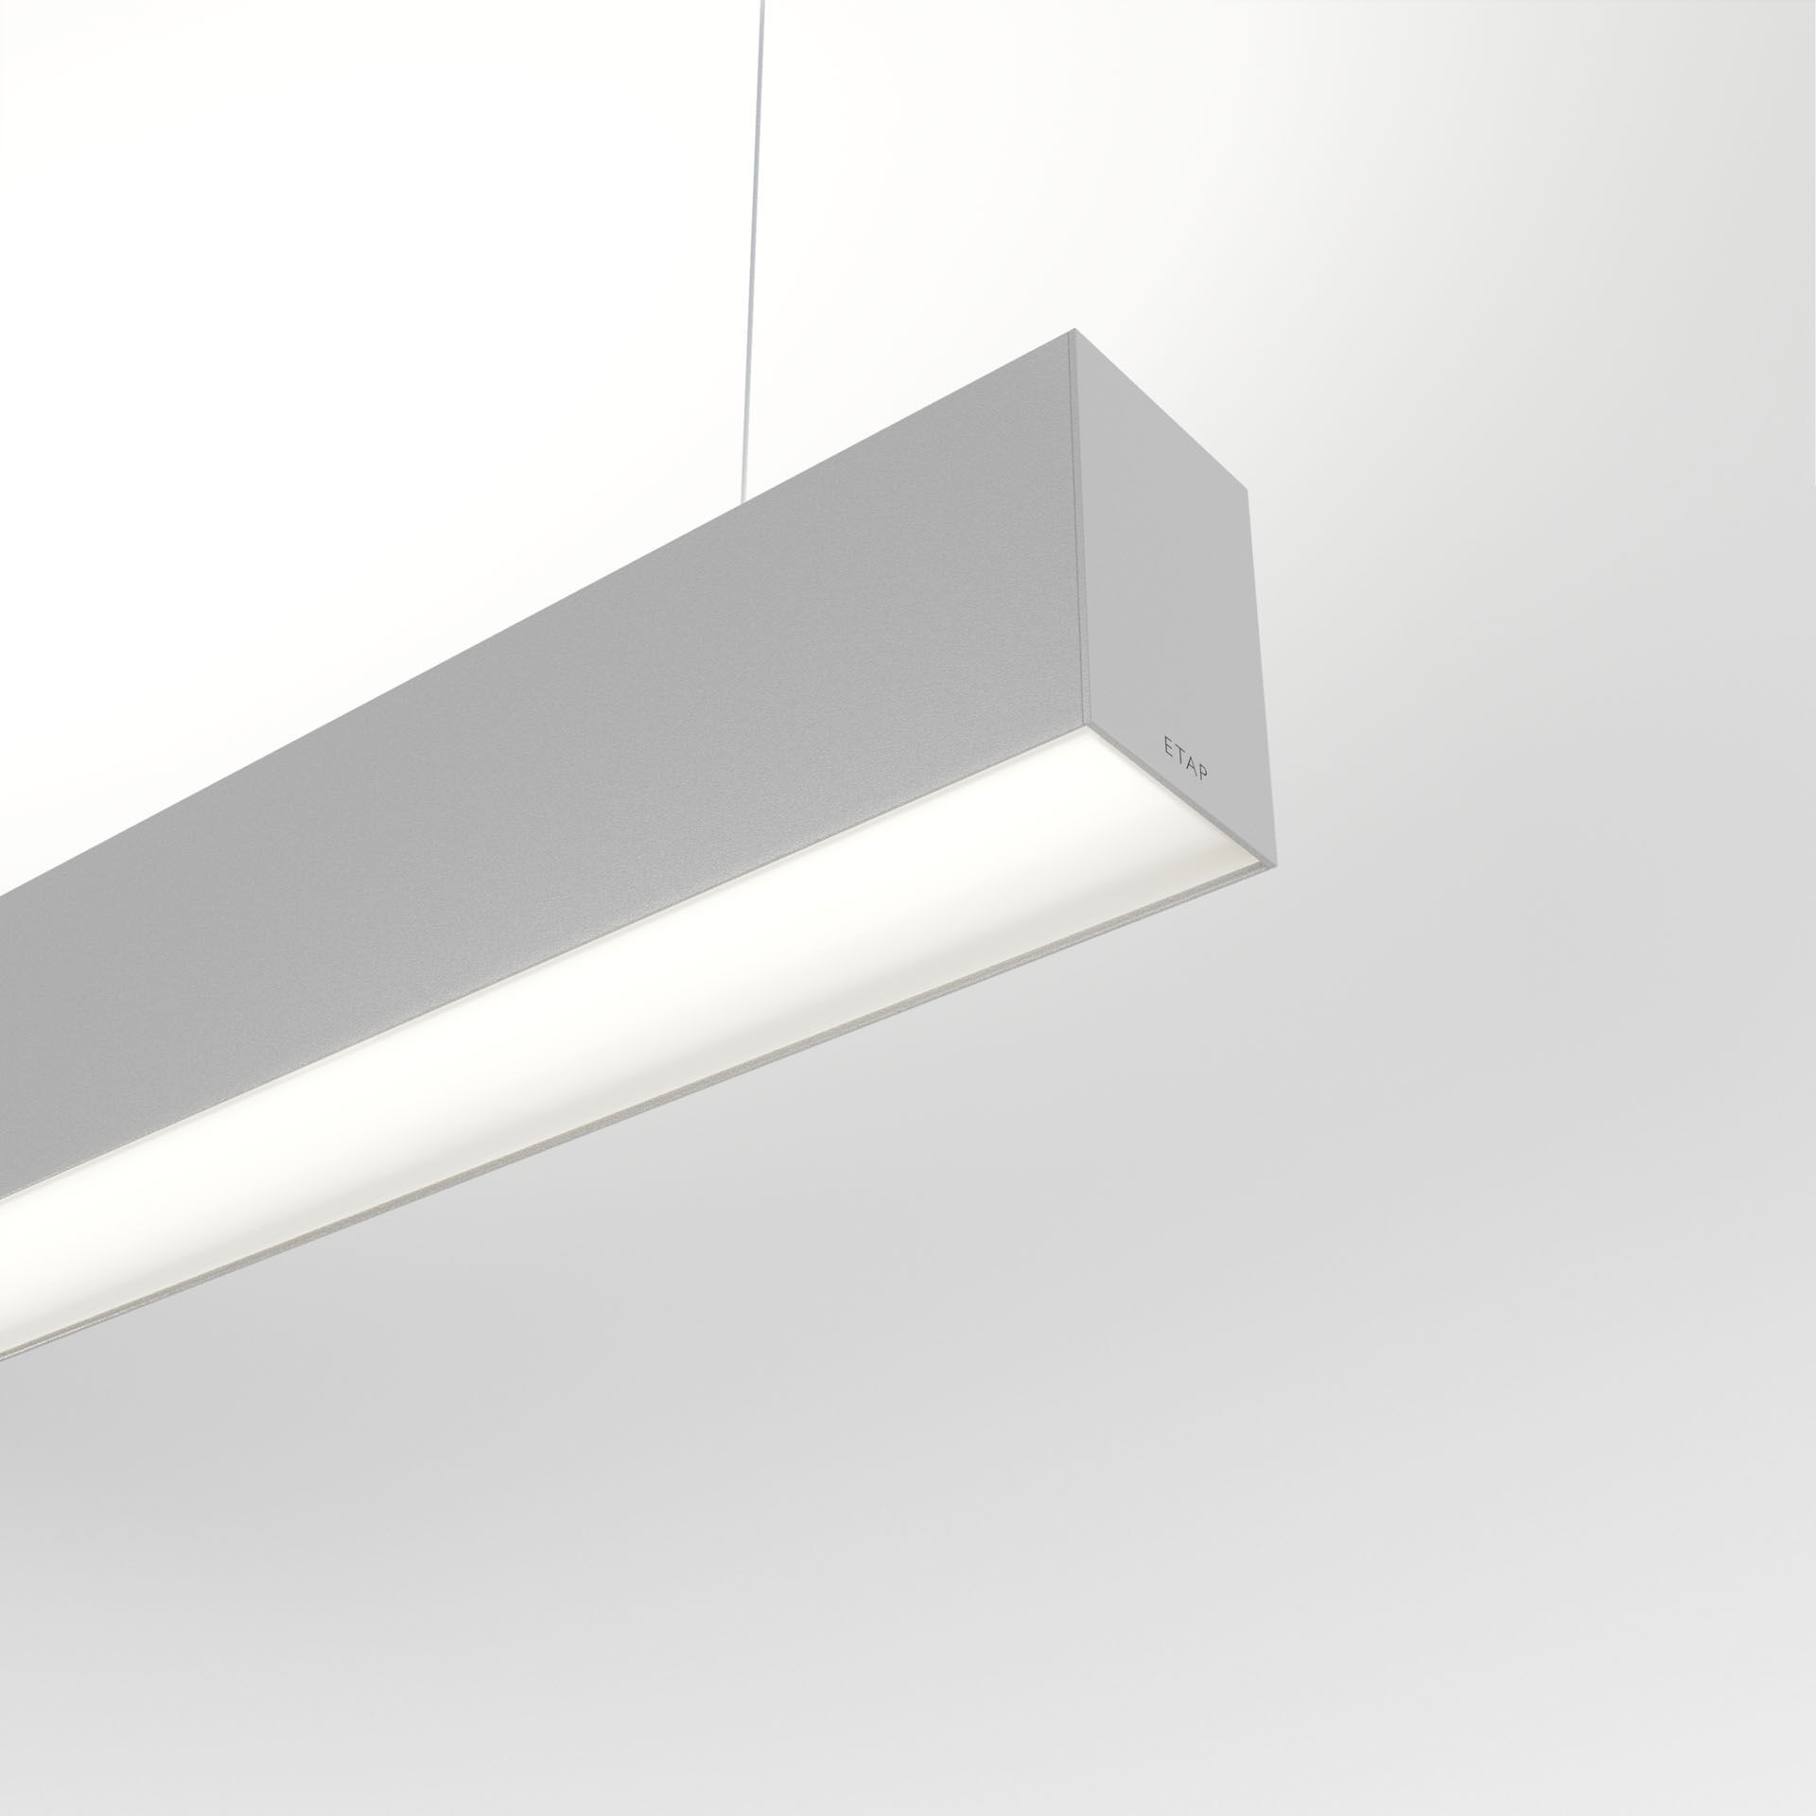
Architectural light line luminaire. Diffuser optics, opal acrylic (PMMA), wide-angle light distribution. Dimensions: 1403 mm x 60 mm x 90 mm. Flat panel diffuser for bright and uniform illumination. Luminous flux: 5100 lm, Luminous efficacy: 135 lm/W. Power: 37.8 W, DALI dimmable. Frequency: 50-60Hz AC. Voltage: 220-240V. Electrical isolation class: class I. LED with very good light maintenance; at 50000 hrs the luminaire retains 98% of it's initial flux (Tq=25°C). Correlated colour temperature: 4000 K, Colour rendering ra: 80. Standard deviation colour matching satisfy 3 SDCM. Photobiological safety IEC/TR 62778: RG1. Lacquered aluminium housing, RAL9006 - white aluminium (textured). IP protection level: IP20. IK protection level: IK07. Glowwire: 850°C. 5 years warranty on luminaire and driver. Certifications: CE, ENEC. Luminaire with halogen free leads. The luminaire has been developed and produced according to standard EN60598-1 in a company that is ISO9001 and ISO14001 certified. Mandatory accessoires for mounting the luminaire: ACC-HI00-X02, V3-HI01-5P-1500, V3-HI02-5P-1500.

