V3SDJ0M/W9LLD0X0

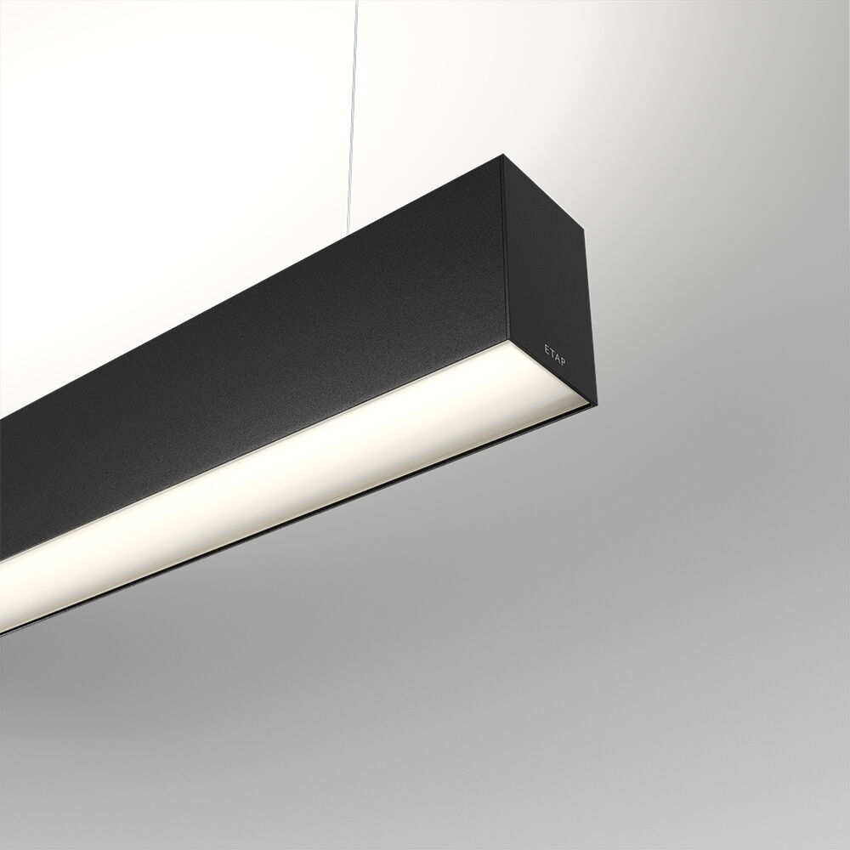
Architectural light line luminaire. Diffuser optics, opal acrylic (PMMA), wide-angle light distribution. Dimensions: 2523 mm x 60 mm x 90 mm. Flat panel diffuser for bright and uniform illumination. Luminous flux: 8800 lm, Luminous efficacy: 128 lm/W. Power: 68.7 W, DALI dimmable. Frequency: 50-60Hz AC. Voltage: 220-240V. Electrical isolation class: class I. LED with very good light maintenance; at 50000 hrs the luminaire retains 0% of it's initial flux (Tq=25°C). Correlated colour temperature: 3000 K, Colour rendering ra: 80. Standard deviation colour matching satisfy 3 SDCM. Photobiological safety IEC/TR 62778: RG1. Lacquered aluminium housing, RAL9005 - jetblack (textured). IP protection level: IP20. IK protection level: IK07. Glowwire: 850°C. 5 years warranty on luminaire and driver. Certifications: CE, ENEC. Luminaire with halogen free leads. The luminaire has been developed and produced according to standard EN60598-1 in a company that is ISO9001 and ISO14001 certified. Mandatory accessoires for mounting the luminaire: ACC-HI00-X00, V3-HI01-5P-1500, V3-HI02-5P-1500.

