V3SS30M/W5MMD0X0

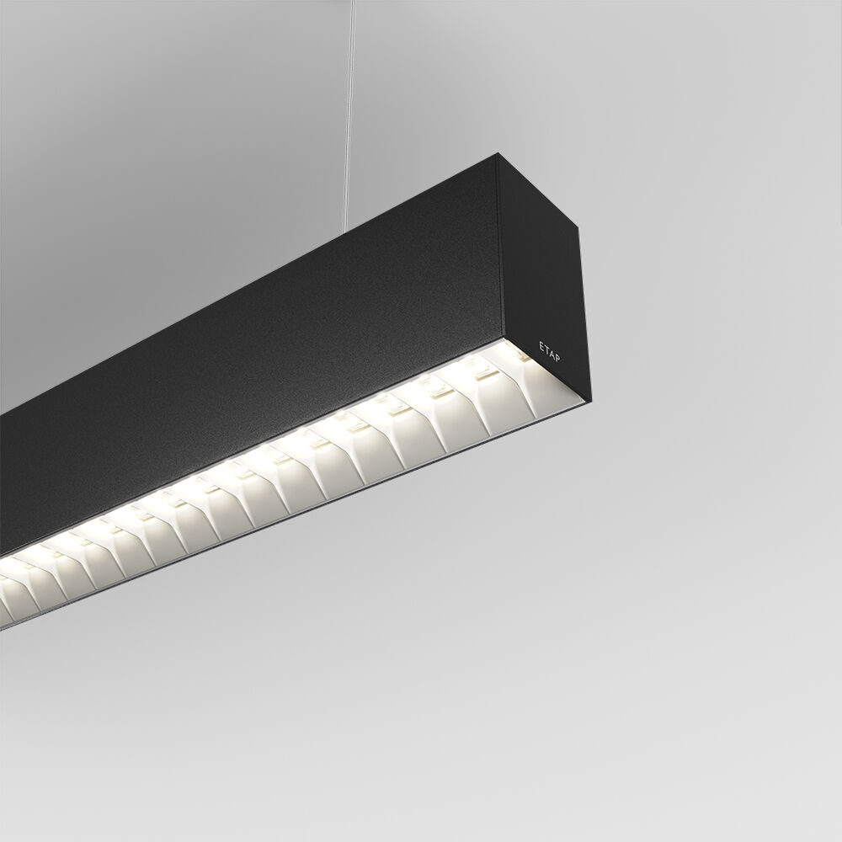
Architectural light line luminaire. . Dimensions: 2283 mm x 60 mm x 90 mm. Luminous flux: 6600 lm, Luminous efficacy: 140 lm/W. Power: 47.2 W, DALI dimmable. Frequency: 50-60Hz AC. Voltage: 220-240V. Electrical isolation class: class I. Correlated colour temperature: 3000 K, Colour rendering ra: 80. Colour consistency (McAdam ellipse): ≤ SDCM. Photobiological safety IEC/TR 62778: RG1. RAL9005 - black. IP protection level: IP20. IK protection level: IK07. Energy efficiency class of the light source according to EU regulation 2019/2015: C. Glowwire: 650°C. 5 years warranty on luminaire and driver. Certifications: CE, ENEC. Luminaire with halogen free leads. The luminaire has been developed and produced according to standard EN60598-1 in a company that is ISO9001 and ISO14001 certified. Mandatory accessoires for mounting the luminaire: ACC-HI00-X00, V3-HI01-5P-1500, V3-HI02-5P-1500.

