V3UB10M/N3M0D0X2

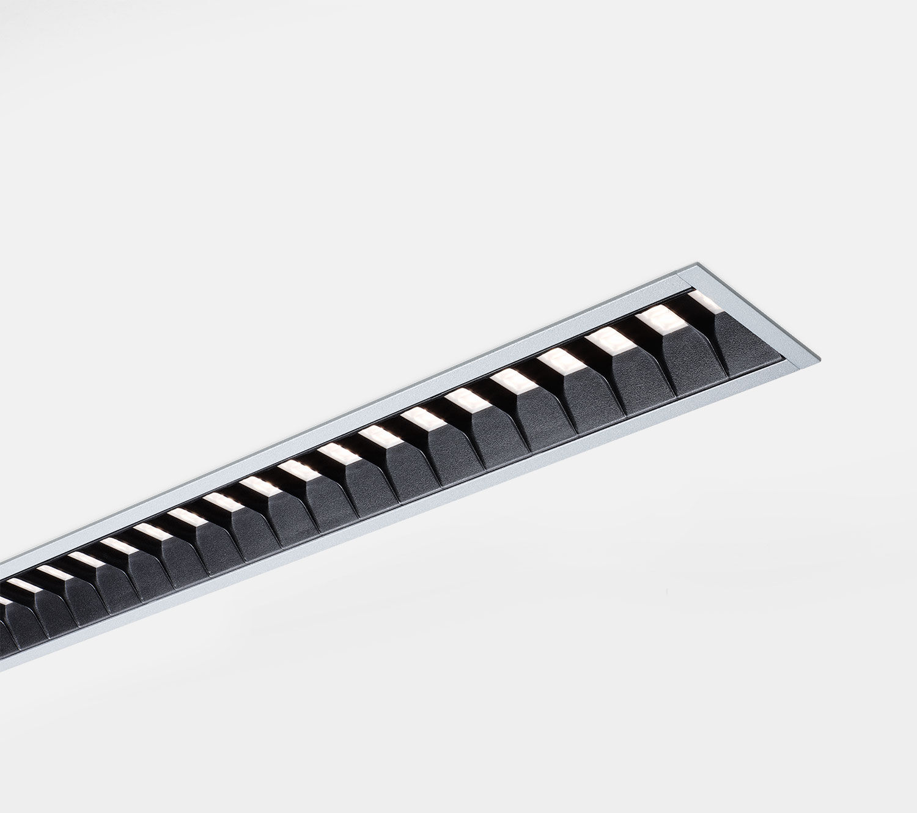
Architectural light line luminaire. Shielded lens optics, black polycarbonate (PC), medium wide-angle light distribution. Dimensions: 1385 mm x 76 mm x 72 mm. Individual linear Shielded lens: the light source is hidden from view by shielding units, the light distribution is made with a lens. Two lenses per shield cavity. Luminous flux: 2800 lm, Luminous efficacy: 120 lm/W. Power: 23.3 W, DALI dimmable. Frequency: 50-60Hz AC. Voltage: 220-240V. Electrical isolation class: class I. LED with very good light maintenance; at 50000 hrs the luminaire retains 96% of it's initial flux (Tq=25°C). Correlated colour temperature: 4000 K, Colour rendering ra: 80. Colour consistency (McAdam ellipse): ≤ SDCM. Shielded lens for glare-free light distribution with UGR <= 19 and luminances @ 65° 3000 Cd/m² conform norm EN 12464-1 for high visual demands, e.g. display screen equipment. Photobiological safety IEC/TR 62778: RG1. Lacquered aluminium housing, RAL9006 - aluminium grey. IP protection level: IP20. Energy efficiency class of the light source according to EU regulation 2019/2015: C. Glowwire: 650°C. 5 years warranty on luminaire and driver. Certifications: CE, ENEC. Luminaire with halogen free leads. The luminaire has been developed and produced according to standard EN60598-1 in a company that is ISO9001 and ISO14001 certified.

