V3UB10M/W5M0D0X0

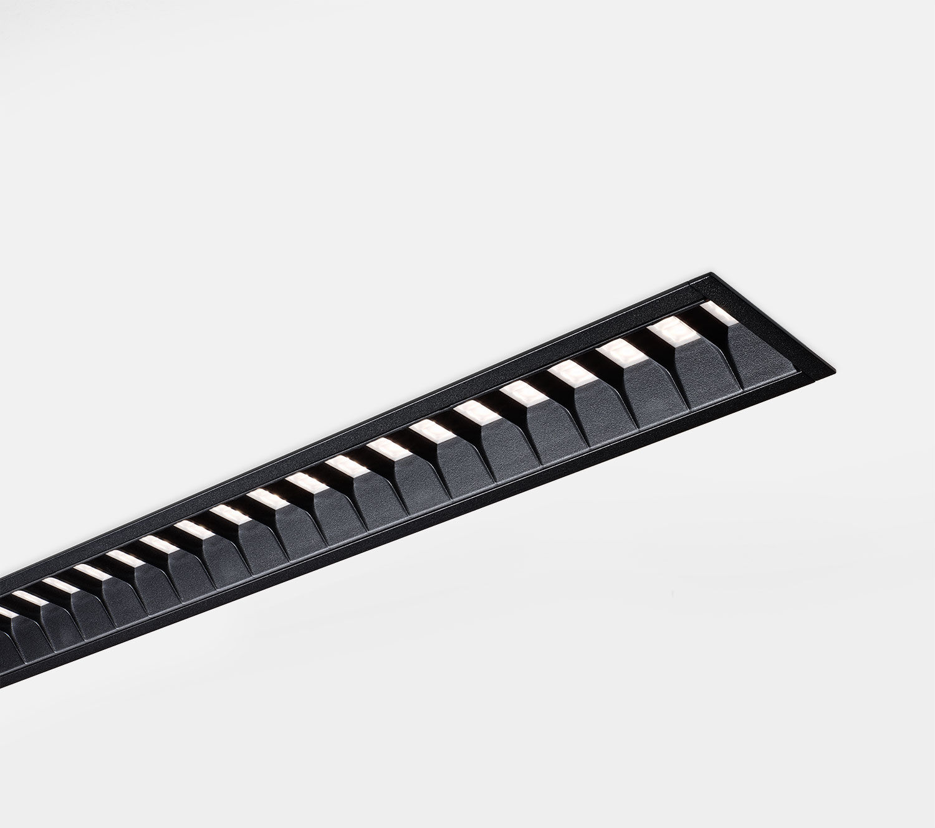
Architectural light line luminaire. Shielded lens optics, black polycarbonate (PC), medium wide-angle light distribution. Dimensions: 2297 mm x 76 mm x 72 mm. Individual linear Shielded lens: the light source is hidden from view by shielding units, the light distribution is made with a lens. Two lenses per shield cavity. Luminous flux: 4500 lm, Luminous efficacy: 121 lm/W. Power: 37.3 W, DALI dimmable. Frequency: 50-60Hz AC. Voltage: 220-240V. Electrical isolation class: class I. LED with very good light maintenance; at 50000 hrs the luminaire retains 95% of it's initial flux (Tq=25°C). Correlated colour temperature: 3000 K, Colour rendering ra: 80. Colour consistency (McAdam ellipse): ≤ SDCM. Shielded lens for glare-free light distribution with UGR <= 19 and luminances @ 65° 3000 Cd/m² conform norm EN 12464-1 for high visual demands, e.g. display screen equipment. Photobiological safety IEC/TR 62778: RG1. Lacquered aluminium housing, RAL9005 - black. IP protection level: IP20. Replaceable (LED only) light source by a professional. Replaceable control gear by a professional. Energy efficiency class of the light source according to EU regulation 2019/2015: C. Glowwire: 650°C. 5 years warranty on luminaire and driver. Certifications: CE, ENEC. Luminaire with halogen free leads. The luminaire has been developed and produced according to standard EN60598-1 in a company that is ISO9001 and ISO14001 certified.

